

National Crime and Policing Measures

Q4 2023/24

Introduction
The Government’s National Crime and Policing Measures (NCPM) are intended to compliment the local priorities that are set out in Police and Crime Commissioners’ (PCC) Police and Crime Plans; nonetheless the Government is clear that forces must achieve significant reductions in crime and restore the public’s confidence in the criminal justice system. The six key priorities of the NCPM are: -
- Reduce murder and other homicides.
- Reduce serious violence.
- Disrupt drugs supply and county lines.
- Reduce neighbourhood crime.
- Tackle cyber-crime.
- Improve satisfaction among victims – with a particular focus on victims of domestic abuse.

Specified Information Order
In August 2021, the ‘Elected Local Policing Bodies (Specified Information) (Amendment) Order 2021’ came into effect, requiring PCCs to publish information relating to a police force’s performance against the NCPM and thereby enabling greater public scrutiny of police performance and to allow the electorate to hold PCCs to account more effectively. The order states that: -
- PCCs are required to provide a statement on the contribution of their force to achieving improvements against those priorities.
- The information must be published in a prominent place on the PCC’s website. The purpose of this requirement is to make it as easy as possible for the public to access the information, and quarterly updates should be made following the publication of quarterly crime statistics.

Statement of Contribution.
On 31 March 2022, the Warwickshire Police and Crime Commissioner (PCC) formally published the ‘Police and Crime Plan 2021-2025’. The objectives set within the plan have been formulated with consideration of the requirements of the NCPM.
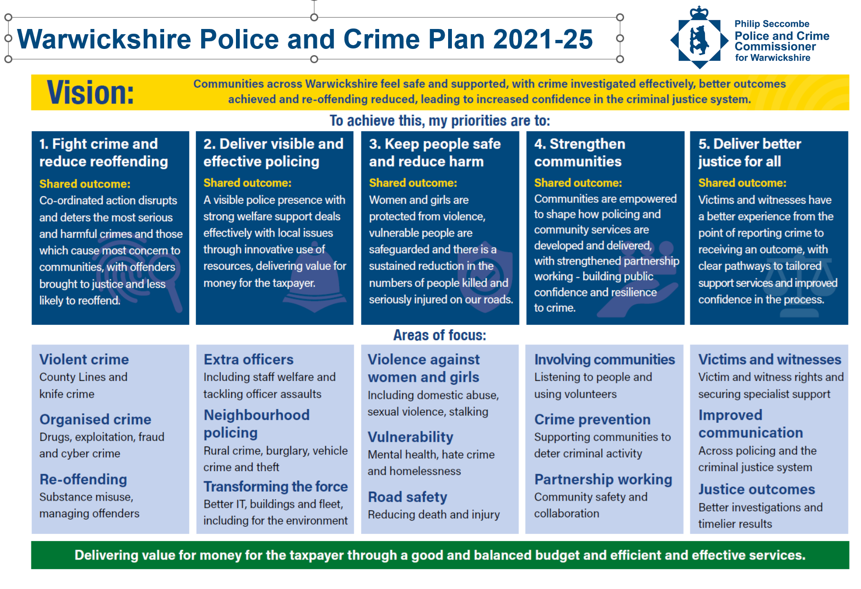
Figure 1 – Police and Crime Plan 2021-25 ‘Plan on a Page’.
The PCC wants to ensure that all agencies are working together to reduce crime, support victims and make communities safer, to ensure delivery against the NCPM priorities. This collaboration is achieved through regular engagement with local communities, the police, partners, and community safety organisations. The PCC’s position as the Chair of the Local Criminal Justice Board also enables him to monitor the provision of an effective and efficient criminal justice system in Warwickshire.
In terms of the PCC responsibilities to ‘hold to account’ the Chief Constable for the performance of Warwickshire Police, the PCC holds a formal monthly ‘Governance and Performance Board’ (GPB) meeting with the Chief Constable. The purpose of the GPB is to focus on specific areas of force performance and is attended by senior officers and staff from the force and the Office of the Police and Crime Commissioner (OPCC). The minutes of the meetings are published on the OPCC website. At each GPB a topical ‘Focus subject’ of particular interest is selected for in-depth scrutiny and discussion.

Warwickshire Police Overview
The Govt. baseline for NCPM is the performance data for 2019 and there are specific measures for the six priority areas. The Home Office recognise that not all measures will apply equally to every force, so PCCs must consider how best to apply these measures in their force area. Warwickshire Police has therefore selected some additional proxy measures to assess the force’s contribution towards these national priorities and the force will continue to develop its approach to ensure that the measures are aligned with the national position.
This report has principally been prepared through scrutiny of the performance data provided in Warwickshire Police’s monthly performance reports for Q3 2023/24: -
- Performance Monthly Insights – March 2024.
- Performance Monthly Insights – February 2024.
- Performance Monthly Insights – January 2024.
A summary of the force’s and OPCC position, with commentary, is provided as follows.

Reduce Murder and Other Homicides

5.1 Force data
In 2023/24, there were five homicides recorded, an increase on the four recorded in the previous year. In Q4 2023/24, there were no homicides recorded.
The Home Office identify an ‘outlier’ when it has experienced an increase equal or greater than five homicides (negative outlier), or a decrease equal or greater than five homicides (positive outlier), between the latest six-month period and the equivalent six-month period in the previous year. Warwickshire Police is therefore not considered to be an ‘outlier’.

5.2 OPCC commentary
Murder and homicides are allied to the subject of Serious Violence and are therefore discussed in the following section.

Reduce Serious Violence
The Govt. measures are: -
- Offences involving the discharge of a firearm.
- Hospital admissions for persons under 25 years old injured with sharp instrument (NHS measure).
The force’s proxy measures are: -
- Serious violence (Violence with Injury / Robbery).
- Offences involving knife crime or sharp instruments.
- Offences involving the use of a firearms.

6.1 Force data

Serious Violence
- Violence with Injury
In 2023/24, volumes (n=4,855) increased by +3% on the previous year.
In March 2024, volumes (n=369) increased by +2.5% on the previous month and were in line with both the 3-year average and forecast.
The December 2023 performance report made a recommendation to focus on improving the ‘action taken’ outcome rate. It is therefore positive to note that in March 2024, the 3-month rolling average ‘action taken’ outcome rate was at 21.4% - a very notable achievement!
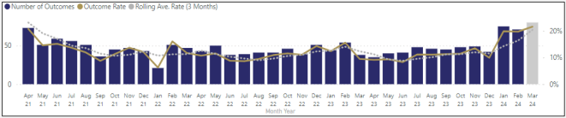
Figure 2 – Violence without Injury ‘action taken’ outcome rates.
- Robbery
In 2023/24, volumes (n=347) increased by +5% on the previous year.
in March 2024, volumes (n=40) increased by +60% on the previous month, predominately driven by increase in north Warwickshire. There appears to be no common theme to these offences.
A question was raised in the Q2 2023/24 OPCC Performance Scrutiny report regarding the specific measures the force were taking to improve the ‘action taken’ rates for robbery. The force’s position will continue to be monitored by the OPCC.

Knife Crime
The Home Office data collection for offences involving knives or sharp instruments is limited to selected offences and certain weapon types. It excludes possession offences. Knife crime is not a designated Home Office crime category.
The force’s Annual Data Return for 2023/24 shows a -20% reduction in knife crime when compared to the previous year – a positive position!
In March 2024, volumes (n=21) decreased by -5% on the previous month. There is no data provided in respect of the ‘action taken’ outcome rates.

Firearms
The Home Office data collection reports on offences where a firearm was used as a ‘threat’.
In 2023/24, volumes (n=64) increased by +20% (n=+11) on the previous year.
In Q4 2023/24, there were 16 firearms offences recorded, none resulting in fatality or serious injury. This volume of offences is broadly consistent with the previous quarter.

6.2 OPCC commentary
The Warwickshire Strategic Needs Assessment for Serious Violence is now complete and has informed a refresh and relaunch of the county’s Serious Violence Prevention Strategy. Both items were required because of the new Serious Violence Duty. This work continues to be led by Warwickshire County Council on behalf of all duty holders, driven through the Serious Violence Partnership Delivery Group. It is closely overseen and supported by the OPCC, as the conduit to the Home Office for governance and reporting purposes.

Disrupt Drugs and County Lines
The Govt. measures are: -
a) Drug Related Homicide.
b) Police Referred Drug Treatment (supplied by Public Health England).
The force’s proxy measures are: -
a) Drug related homicides.
b) Organised Crime Group (OCG) disruption.

7.1 Force data

Drug Related Homicide.
This information is not included in the performance reports. A question was therefore raised in the in the Q2 2023/24 OPCC Performance Scrutiny report regarding what arrangements are to be made for the capture of NCPM data in respect of the of Drug related homicide. The response provided by Warwickshire Police in respect of drug related homicide was that due to the low volume of homicide within the county, the force does not disaggregate this information within the performance framework, but data is provided nationally, accessed through the Digital Crime and Performance Pack (DCPP).

OCG Disruption
In 2023/24 there were 4 major; 13 moderate; 83 minor disruptions of Organised Crime Groups in Warwickshire.
In Q4 2023/24, there were 30 approved OCGs disruptions in the county. Also, that 3 adults and 7 children were safeguarded during this period.
Given the complexity and sensitivity of OCGs and County-lines activity, which predominately involves cross-border crime, qualitative comment cannot be provided without further context, the nature of which is sensitive information.
7.2 OPCC commentary
Information regarding drug related homicide is not specifically included in the performance reports. Recent homicide investigations are currently ‘live’ and therefore the relationship between the deaths and controlled drugs is not presently a consideration for this report.
A key priority for the Police and Crime Plan 2021-2025 is to Fight Crime and Reduce Reoffending, with a focus on Violent Crime and Organised Crime. The Plan provides a narrative as to how this will be achieved and the measures by which the success of the plan will be measured. The OPCC has consequently worked closely with Warwickshire Police, Warwickshire County Council (WCC), and other partners, to review the necessary partnership governance and oversight arrangements for Serious Organised Crime (SOC), recognising the links from this to Serious Violence (SV), and to develop and propose new arrangements that are fit for the future. This review concluded with the introduction of a revised partnership governance and delivery structure for both SOC and SV, overseen by a new Executive Group.
Work is now underway to establish to implement Operation Stronghold, which is Warwickshire’s branding for the nationally mandated ‘Clear, Hold, Build’ intervention methodology.
The PCC continues to closely monitor performance and ‘hold to account’ the Chief Constable in this area of considerable public concern.
The PCC commissions criminal justice related drug and alcohol misuse services for the county, to try and break the link between substance misuse and offending behaviour.

Reduce Neighbourhood Crimes
The Govt. measures are: -
a) Burglary.
b) Theft from, and of, vehicle (Crime Survey England & Wales - CSEW).
c) Theft from Person.
The force’s measures are: -
- & b) & c) Home Office Crime Recording categories

8.1 Force data

Burglary (Home)
In 2023/24, volumes (n=1,107) decreased by -2% on the previous year.
In March 2024, volumes decreased by -6% on the previous month and remained in-line with the 3-year average for this high-harm offence type of significant public concern, as the below graph illustrates: -
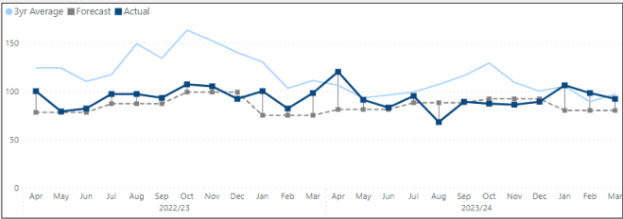
Figure 3 – Burglary (Home) Volumes.
The north of the county saw a +17% increase on the previous month. This is the second consecutive month where the north has seen the most car key burglaries, with many of the offences located around new build developments in the Nuneaton & Bedworth district.
The recommendation in the performance report was noted, regarding Corporate Communications to consider raising awareness around car key burglary prevention via social media and leaflet drops to high-risk properties.
In March 2024, the 3-month rolling average ‘action taken’ outcome rate was at 7.4%, a notable improvement on the 4.4% that was reported for Q3 2023/24.

Vehicle Crime
In 2023/24, volumes (n=4,090) decreased by -13% on the previous year.
In March 2024, volumes (n=379) increased by +30%, with theft from vans in hotel locations being a noticeable theme.
The recommendation in the performance report was noted, regarding identifying repeat locations for van offences and brief prepared with a Problem-Solving Plan to be adopted.
In March 2024, the ‘action taken’ outcome rate was at 2.9%, a notable improvement on the 3-month rolling average of 1.9%.
A question was raised in the Q2 2023/24 OPCC Performance Scrutiny report regarding the specific measures the force were taking to improve the ‘action taken’ outcome rates for vehicle crime. The force’s position will continue to be monitored by the OPCC.

Theft from Person
In 2023/24, volumes (n=258) were consistent with the previous year.
In March 2024, volumes (n=9) reduced by -31% on the previous month. The ‘action taken’ outcome rates remain mercurial given the low number of offences recorded.

8.2 OPCC commentary

Burglary
In the Q3 2023/24 report it was commented that the force’s performance would continue to be monitored and scrutinised in the expectation that improvement will be made in the ‘action taken’ outcome rate Q4 2023/24. It is therefore a positive development that the rate has substantially improved.

Vehicle crime
The Home Office has previously identified Warwickshire Police as an outlier, a position driven by comparison with the force’s performance with its Most Similar Group (MSG) of police forces - Warwickshire has historically suffered due to its proximity to the metropolitan West Midlands area and its crime profile.
Given the latest performance data, the PCC will ‘hold to account’ the Chief Constable on these matters at the Governance Performance Board, to ascertain what proactive measures the force is implementing to mitigate against these series of offences and improve the ‘action taken’ outcome rates.

Theft from Persons
The levels are comparable to the 3-year average and as such no further comment is made.

Victim Satisfaction
The Govt. measures are: -
a) Victim satisfaction with police by victims of domestic abuse.
b) Victim satisfaction with police (CSEW) - Not available.
The force’s proxy measures are: -
- Force’s own domestic abuse victim satisfaction survey (not comparable with other forces).
- Victim satisfaction surveys.

9.1 Force data
Of note is that Warwickshire Police has now set ‘target rates’ for Victim Satisfaction. In March 2024, the rolling 6-month ‘whole experience satisfaction’ trend delivered the following levels of performance: -
- Domestic Abuse 75% < Target 80%
- Vehicle Crime 64% < Target 70%
- Violence 68% < Target 75%
- Burglary 75% < Target 80%
- Hate Crime 72% < Target 80%
The March 2024 in-month figures demonstrated recent improvements in victim satisfaction for Domestic Abuse (82%) and Vehicle Crime (70%) and Burglary (85%).
A question was raised in the Q2 2023/24 OPCC Performance Scrutiny report regarding victim satisfaction rates, with particular concern regarding the poor ‘follow-up’ measure for Burglary victims. It is therefore a positive development that there has been considerable improvement in this specific area of performance with all Burglary (Home) investigations being allocated to detectives in the Serious Acquisitive Crime Teams. The force’s position in respect of victim satisfaction across all measures will continue to be monitored by the OPCC.

9.2 OPCC commentary
The recent in-moth increase in victim satisfaction for certain offence types is a positive development. The force’s performance will continue to be monitored and scrutinised in the expectation that further improvement in satisfaction rates will be made 2024/25. in Q4 2023/24.
The recent introduction by the force of a Crime Control Centre (CCC) should assist in achieving this aim. The purpose of the CCC is to focus on effective investigation management through identifying those crimes which have the best chance of being solved with a positive outcome for the victim. This should mean that there is more time to carry out investigations and to engage with the victim according to their needs in accordance with the Victims Code.
The OPCC works closely with Warwickshire County Council and other partners in delivering the aims of the county’s ‘Violence Against Women and Girls (VAWG) Strategy’. This has included reviewing the governance arrangements and working closely to link the work of the county’s VAWG Board with the work of the Local Criminal Justice Board (LCJB). This is particularly important in relation to progress to improve criminal justice outcomes for victims of Sexual Violence and Domestic Abuse.
The PCC commissions the following services for victims in Warwickshire: -
- General victim support: Victim Support
- Sexual violence and abuse: Safeline
- Child exploitation: Barnardo’s
- Restorative Justice: Victim Support
- Modern Slavery and Human Trafficking: West Midlands Anti-Slavery Network

Tackle Cyber Crime
The Govt. measures are: -
a) Confidence in law enforcement response.
b) Percentage of businesses experiencing cyber-crime. Data taken from non-police sources.
The force’s proxy measures are: -
a) Action Fraud cyber-dependent victim referrals where advice given.

10.1 Force data
Information not included in the Performance Reports. A question was therefore raised in the in the Q2 2023/24 OPCC Performance Scrutiny report regarding what arrangements are to be made for the capture of NCPM data in respect of the of Cyber-crime and their inclusion in the performance reports. The response provided by Warwickshire Police in respect of cyber-crime was that the force currently reports cyber-crime measures through the Proactive and Preventative Steering Group (P&PSG). Cyber Crime reporting is transitioning to APMIS, the national system for recording cyber disruptions. This measure will soon be also available through the DCPP tool and disaggregated to Warwickshire.

10.2 OPCC commentary
Cyber-crime is another significant activity of Serious and Organised Crime, often international in its origin and scope. Supporting victims of cyber-enabled and / or cyber-dependent crime is a priority for Victim Support, who the PCC commissions to support victims of crime in Warwickshire. Of note is that Action Fraud as the national agency for the collation and dissemination of fraud offences is to be replaced to ensure that victims are given a more accessible and customer friendly service, and ensuring the right crimes are disseminated with expediency across policing.
The Deputy Police and Crime Commissioner is now a Board member for the Cyber Resilience Centre for the West Midlands that supports and helps protect small business, SMEs, and supply chain businesses and third sector organisations in the region against cybercrime.
An in-depth review of the force’s response to ‘Cybercrime – Fraud’ has been conducted and a report produced for the information of the Police and Crime Panel.

