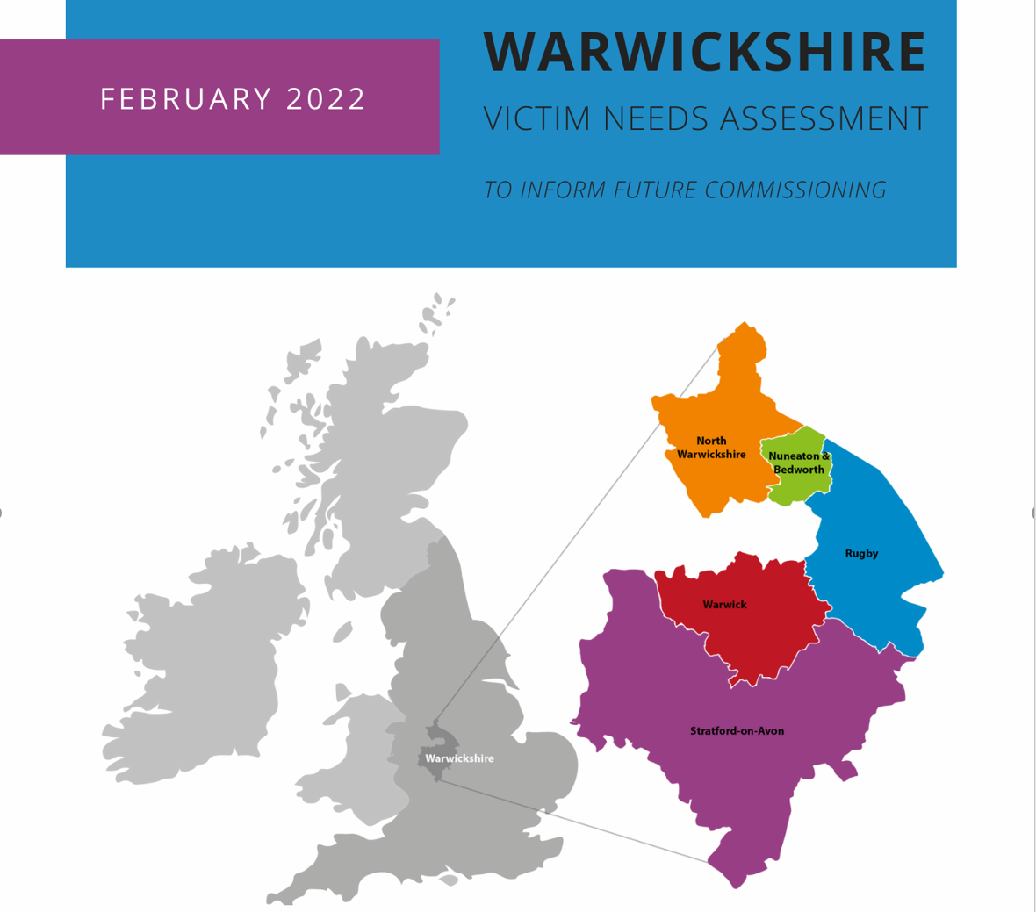
EXECUTIVE SUMMARY

Background and Context

Across England and Wales, there was a 14% increase in total crime between 2019 and 2021, driven by a 47% increase in fraud and computer misuse. Latest estimates reveal that around 2 in 10 adults were a victim of crime in the year ending September 2021, with this most commonly being fraud (8.9%), computer misuse (3.6%), criminal damage (2.9%), and vehicle-related theft (2.9%). However, a smaller but significant percentage experience more inter-personal crimes such as violence (2.0%), burglary (1.7%), and theft or robbery from the person (0.6%). A distinct link has also been established between substance use and criminal activity, with 40% of violent crimes believed to be alcohol related and 45% of acquisitive crime related to opioid or crack cocaine use.

Specifically in Warwickshire, in 2020-21, police recorded 36,635 crimes, with a further 4,006 fraud offences, and 16,741 incidents of anti-social behaviour.

It is well documented that the impact of crime on victims can be far reaching, including physical and emotional injury, long-term psychological and mental health effects, negatively influencing future trust, sense of fear, and feelings of safety, all of which can impact on various aspects of a victims’ life, consequently meaning crime is extremely costly to society. Accordingly, there has been a shift in the culture of the criminal justice system to recognise the importance of better engaging with, and supporting the needs of, victims.

The Office of the Police and Crime Commissioner (OPCC) for Warwickshire currently commission a range of services to support victims and survivors of crime as well as those involved in the Criminal Justice System with substance use related issues. The contracts for these services are due to conclude on 31/03/2023; accordingly, the OPCC has commenced a new commissioning cycle which will determine the best ways to support victims and survivors moving forward. As part of this, the OPCC commissioned social research organisation TONIC to conduct a comprehensive Victim Needs Assessment (VNA), reviewing levels of need and current provision to ensure services are appropriately responsive and equitably meeting need throughout the county and across all victim groups, populations, and communities. There was a particular focus on:

- General Victim Recovery Services
- Vulnerability-related specialist support services for victims of:
  - Sexual Abuse and Violence (SAV)
  - Child Exploitation (CE)
  - Modern Slavery and Human Trafficking (MS/HT)
- Criminal Justice related Drug and Alcohol Abuse Services (for both adults and children)

For each element, the needs of victims and survivors in relation to any relevant protected characteristics (such as age, gender, ethnicity, and disability) were considered.

Design, Methodology, and Sample Overview

To undertake this VNA, TONIC conducted the following work, which engaged over 400 local victims and professionals:
- Literature review of existing research, surveying, and synthesising both national and international literature, to provide insight into the current understanding and knowledge.
- Quantitative data analysis covering national trends in crime, local police recorded crimes, witness care data including court cases, and referral and intervention information alongside demographic data of those accessing the commissioned services.
- Surveys reaching 327 people, including 121 victims and service users, 14 respondents on behalf of someone with lived experience, 84 frontline practitioners and service providers, and 80 key stakeholders.
- In-depth interviews and focus groups with 94 people, including 17 victims and service users, 35 frontline practitioners and service providers, and 42 key stakeholders.

Key Findings

TONIC produced a detailed report outlining overarching themes considering the impact of the COVID-19 pandemic, bringing to light serious issues with data reporting, recording, and sharing, highlighting barriers and challenges to access and engagement, and exploring ways to promote inclusivity. In addition, TONIC evaluated existing commissioned services in depth, providing service-specific feedback, highlighting their strengths and opportunities to expand provision and reach the growing demand, as well as exploring options for better supporting victims of Modern Slavery and Human Trafficking in Warwickshire in the future.

Current Commissioned Services are meeting the Needs of Victims in Warwickshire
Throughout the VNA, there was an overwhelming consensus that specialist victims support services are required, and we received a significant amount of very positive and encouraging feedback about the current commissioned services being delivered by qualified, experienced, passionate, and dedicated teams who go ‘above and beyond’ to support their service users. There was evidence of service providers adopting person-centred care and taking an individualised approach to support, based on the individual’s needs. Participants were all able to express what they felt victims of crime need and want from support services, which came down to providing both emotional and practical support options (even if the latter was via signposting), and effective communication – having somebody to talk to, who will genuinely take the time to listen and then advocate for them. Generally, interviewees felt that the current providers are effectively meeting these. All service providers described a growing demand for their services, which can be evidenced from many of the commissioned service’s quantitative data. Practitioners expressed a desire to be able to do more.

Impact of COVID-19 Pandemic
As with many other sectors, the pandemic has both created new challenges for commissioned services and been a catalyst for change. Although demand for support rose and collaboration between services deteriorated in this period, services have been able to explore new delivery models, particularly online support options. Provided they do not create new barriers and are not used as a replacement for face-to-face support options, remote delivery methods are likely to have a positive and lasting impact on accessibility and may increase efficiency.

Areas for Development
It is important to acknowledge that while we received large amounts of positive feedback about the current commissioned support services, there is room for a number of improvements to be made to better meet the needs of victims and individuals using substances. The VNA uncovered issues with data reporting, recording, and sharing within commissioned services and the police more generally, which limits ability to assess a true picture of demand for support services in Warwickshire. Individual frontline workers also appeared to lack of knowledge around complaints procedures, outcome measures and key performance indicators, and it was felt that there is a desperate need for more funding across the board to ensure services can manage and limit the lengthy waiting lists some are starting to accumulate.

Barriers to Engagement
In an attempt to best serve victims in Warwickshire, there is also a need to overcome some of the existing barriers to engagement. Firstly, there are ‘personal’ barriers which are based on an individual’s own perceptions, that can often be influenced by past experiences, for example, feels of shame and embarrassment, fear of judgement or potential negative repercussions. Then there are ‘structural’ or ‘organisational’ barriers such as lack of staff awareness, training, resources, limited promotion of the support available, resource inadequacies, service fragmentation, poor interdisciplinary communication, etc. Finally, and perhaps the biggest issue to tackle, ‘sociocultural’ barriers based on society’s values, beliefs, and attitudes, in particular, there is an undercurrent of mistrust in the Criminal Justice System and policing as a whole at present.

Promoting inclusivity
While all service providers reported that their support is inclusive and that service users are treated equally regardless of any protected characteristics, it is apparent from the quantitative data that there is a need to improve this further. Stakeholders also often raised this as an area for improvement amongst commissioned services. Those from Gypsy Roma Traveller backgrounds were felt to be the most overlooked, and an apparent lack of LGBTQ+ specific support in Warwickshire was described. There were some examples of emerging and good practice among the commissioned services (i.e., dedicated ‘BAME’ worker roles or evolving partnerships with ‘by and for’ organisations), but participants acknowledged that there is still a long way to go in order to reach all victims.

Modern Slavery and Human Trafficking
Throughout the interviews we conducted, no dedicated support services for victims of MS/HT in Warwickshire were identified. Most practitioners openly expressed concerns about not knowing the correct procedure for supporting someone recognised as a victim. Interviewees all described the nature of MS/HT being a particularly hidden crime, and that currently in Warwickshire, nobody really has a concept of level of demand due to police not being proactive in trying to identify victims. This was felt to be even more pronounced for victims of sexual exploitation. There was recognition from interviewees that the current ad-hoc nature of current arrangements with support agencies outside of Warwickshire is no longer sufficient to meet the support needs of victims of MS/HT given that the profile of MS/HT becoming more widely understood. There was agreement amongst interviewees that this is a significant gap in Warwickshire’s support provision. Through interviews, three possible solutions for the future emerged:
- Funding a dedicated, specialist support service for MS/HT victims in Warwickshire.
- Upskilling existing practitioners or recruiting a dedicated MS/HT worker within existing commissioned services to meet the needs of victims.
- Funding to outsource support from another area – the WMASN being the most commonly suggested.

The second and/or third option appeared to be the preference among stakeholder interviewees, with suggestions that a dedicated worker should sit within the General Victims Recovery Service. It was felt that to properly inform future commissioning of MS/HT support services, there is a need for a more detailed and specific needs assessment to be conducted, exploring victims’ needs and attempting to uncover a more accurate picture of the level of demand for supporting victims of MS/HT in Warwickshire.

Service Specific Feedback

Biggest Need | Emotional support  Safety planning  Police and housing advocacy  Support for anti-social behaviour victims
Unique Barriers to Engagement | Lack of awareness of the service  Misconception around being associated with the police
Positive Feedback | Workers are victim-led and ‘go above and beyond’  Free and confidential support  Most positive part of the whole CJS  Ability to signpost to other agencies
Areas for Development | Need for better promotion of the service  Highlight independence from the police  Police to improve quality of their referrals  Streamline referrals for vulnerable/repeat victims
Future Considerations | Support to all victims of crime  Introduce peer support networks  Embed a designated Modern Slavery and Human Trafficking support and outreach worker
Biggest Need | Counselling support
Unique Barriers to Engagement | Lengthy waiting list for counselling  Stigma associated with SAV
Positive Feedback | Staff praised for kind and caring attitude  Staff are experts in their field  Person-centred approach  Supportive team, with high quality clinical supervision  Local service provider promotes survivor confidence
Areas for Development | Lengthy waiting list for counselling support  Helpline can be difficult to manage  Need for better joint working with other SAV services
Future Considerations | Increase outreach work  Introduce creative forms of therapy  More opportunities for staff training and development

Biggest Need | Psychoeducation  Diversionary activities
Unique Barriers to Engagement | Not recognising exploitation or wanting to be separated from exploiter  Fear of punitive repercussions  Concerns for confidentiality
Positive Feedback | Holistic support  Patient practitioners  Not time-bound  Training and Outreach worker role is a key strength
Areas for Development | Increase consistency between workers  Deliver training more flexibly  Attendance and proportionate contribution at all key meetings  Enhance joint working with relevant partners
Future Considerations | Broaden focus to CE more generally, within a contextual safeguarding model  Increase proactive outreach and preventative work  More creative diversionary activities  Expand workshop delivery in schools  Appoint a designated parent/carer support worker

Biggest Need | Support for alcohol and cannabis use  ‘Myth busting’  Harm reduction advice  Mental health support
Unique Barriers to Engagement | Taboo topic  Fear of punitive repercussions  The name ‘Compass’ is not associated with drug and alcohol support
Positive Feedback | Caring staff  Staff are experts in their field  Flexible service  Proactively respond to trends and patterns  Joint working with YJS – universal referrals
Areas for Development | Reduce travel required for practitioners  Improve assertive outreach and engagement with individuals with protected characteristics
Future Considerations | Reintroduce groupwork as soon as possible  Expand workshop delivery in schools
Biggest Need | Support for alcohol, heroin, and cocaine use  Mental health support  Housing support
Unique Barriers to Engagement | Taboo topic  Co-morbid mental health and substance use issues
Positive Feedback | Holistic service  Tailored support  Praised for problem-solving abilities  Being a national provider has benefits
Areas for Development | Improve assertive outreach and engagement with individuals with protected characteristics
Future Considerations | Consider ways to ensure continuity of care for prison leavers

Recommendations

TONIC used all of the findings to inform recommendations which were discussed during a co-design workshop with relevant OPCC leads. Please see the recommendations section of the full report for a more detailed explanation of each recommendation, which we have split into overarching, system-wide issues and service-specific areas for action.

Overarching Points

- Improve data recording and information sharing agreements between commissioned services and key partners.
- Develop clearer, robust referral pathways, and disseminate these to all potential referrers.
- Incorporate the need to raise awareness of the service provision into commissioned services contracts.
- Encourage improvements with joint working and networking between commissioned services and key partners.
- Commissioned services should proactively seek to engage with individuals who have protected characteristics.
- Improve mental health support provision for victims of crime and individuals misusing substances.
- Ensure commissioned services offer a flexible approach to support, with consideration of the location for delivery, to promote accessibility.
- Ensure services are sufficiently resourced to meet the demand and need of service users.
- Consider implementing peer support networks within commissioned services where this can be established and managed safely.
- Increase emphasis on earlier intervention and prevention.
- Continue to gain feedback and enhance this through considering key performance indicators.
- Explore the possibility of dedicated support for victims of Modern Slavery and Human Trafficking in Warwickshire, potentially embedded into the General Victim Recovery Service.
Service Specific Points

General Victim Recovery Service

- Aim to raise awareness amongst the police (new and existing staff) of what the service offers.
- Explore the possibility of contacting every victim of crime who reports an incident to the police in Warwickshire, even if it is just via text message or email, so that they are aware of the service and support available to them, should they need it.
- Discover ways to streamline the referral and triage process for vulnerable/repeat victims, to ensure resources are being deployed as efficiently as possible.
- Ensure every victim is informed about the Victims Codes of Practice (2021), explain this in a jargon-free way so that victims fully understand their rights.
- Focus on supporting CYP victims and explore collaborative working with other services to ensure age-appropriate, holistic, support is offered, with suitable safeguards in place.
- Develop alternative forms of support/signposting for elderly victims who engage in support for prolonged periods of time perhaps due to being lonely. There may be benefits to introducing and utilising peer support networks as a ‘step down’ from professional support to ease the transition to being able to cope independently and reduce social isolation.
- Continue with crime types such as violence (with and without injury) and ‘burglary - dwelling’ remaining key priority areas for the future. Additionally, given the rising trend, increase provision and support for victims of fraud and computer misuse crimes.
- Explore what makes up ‘other’ crime categories when recording and reporting on the experiences of victimisation among clients, to guarantee support is effectively meeting the demand and needs of victims in Warwickshire.
- Enhance joint working policies and procedures with relevant organisations, such as housing providers, in recognition of what support victims most commonly require.

Vulnerability-Related Specialist Support Service for Sexual Abuse and Violence

- Effectively promote the service and support available to survivors across the whole of Warwickshire, including individuals with protected characteristics.
- Work together with other SAV specialist support services in collaboration and partnership rather than in competition, aiming to reduce duplication and share best and emerging practice. To achieve this, services will need clear data and information sharing agreements in place to allow for enhanced multi-agency working.
- Continue to provide therapeutic interventions to those in a survivor’s support network, helping them to cope with the ‘ripple effects’ and in turn assisting to equip them to better support the survivor.
- Expand support provision for instances of child-on-child abuse or child-to-parent abuse.
- Provide survivors access to trauma-focussed counselling as soon after their referral as possible and avoid waiting lists building wherever possible. Where waiting lists do develop, continue providing support via online resources, welfare check ins, or group work, to develop coping strategies and build resilience.
- Explore offering more creative therapy options, such as art and drama therapy, to increase survivors’ choice in their treatment.
- Look to expand specialist provision and outreach to all relevant protected characteristics, given the described success to date of the ‘BAME ISVA’ role.

Vulnerability-Related Specialist Support Service for Child Exploitation

- Ensure a broader focus on CE within a contextual safeguarding model, whilst also maintaining a specialism for CSE, in recognition of differing support needs dependent on the type of exploitation a victim has experienced.
- Consider capacity to appoint a designated parent/carer support worker.
- Provide a consistent approach between workers to guarantee all clients receive an equitable service, whilst tailoring support to the individual’s unique needs.
- Enable practitioners to maintain small caseloads to allow for intensive support and diversionary therapeutic activities.
- Continue to run workshops in schools and expand this provision further where possible, as a means of early intervention and prevention.
- Continue to run training sessions and educational workshops for professionals, delivering these as flexibly as possible, to increase reach.
- Enhance joint working policies and procedures with relevant organisations and ensure attendance and contribution at all relevant meetings.

Criminal Justice Related Drug and Alcohol Service for Adults

- Implement better joint working with the criminal justice related drug and alcohol service for children, particularly to support ‘seamless’ transitions between the services where this is applicable.
- Continue to work to improve continuity of care for prison releases via prison in-reach worker roles.
- Deliver targeted interventions that are responsive to current trends and patterns in substance use.
- Enhance assertive outreach into communities identified as not commonly engaging with the service, work with referrers to explore the apparent lack of diversity amongst the individuals being referred and look to establish new referral pathways that reach all individuals with protected characteristics.
- Continuously consider latest drug strategies, the Prison Strategy White Paper (2021), UK Government 10-year plan, and remember that NICE guidance recommends ‘Mutual Aid’ support and promoting choice within the support that clients can receive.
- Aim to enhance joint working policies and procedures with relevant organisations, given the commonality for those misusing substances to also experience difficulties with their mental health and housing.

Criminal Justice Related Drug and Alcohol Service for Children

- Implement better joint working with the adult criminal justice related drug and alcohol service, particularly to support ‘seamless’ transitions between the services where this is applicable.
- Continue to work in partnership with the Youth Justice Service, and wherever possible aim to improve and enhance communication with the individual workers.
- Continue to work with ‘universal referrals’ and those ‘at risk’ of substance misuse for the purpose of early intervention and prevention.
- Continue to run workshops in schools and expand this provision further where possible by way of early intervention and prevention.
- Reintroduce group work provision as soon as possible, even if this is facilitated virtually, or using a hybrid model of some people attending in person and others participating online.
- Aim to reduce the distance and amount of time that practitioners are travelling between appointments where possible, to increase the amount of time that can be dedicated to supporting clients.
- Enhance assertive outreach into communities identified as not commonly engaging with the service, work with referrers to explore the apparent lack of diversity amongst the individuals being referred and look to establish new referral pathways that reach all individuals with protected characteristics.
- Continuously considers latest drug strategies, the Prison Strategy White Paper (2021), UK Government 10-year plan, and remember that NICE guidance recommends ‘Mutual Aid’ support and promoting choice within the support that clients can receive.
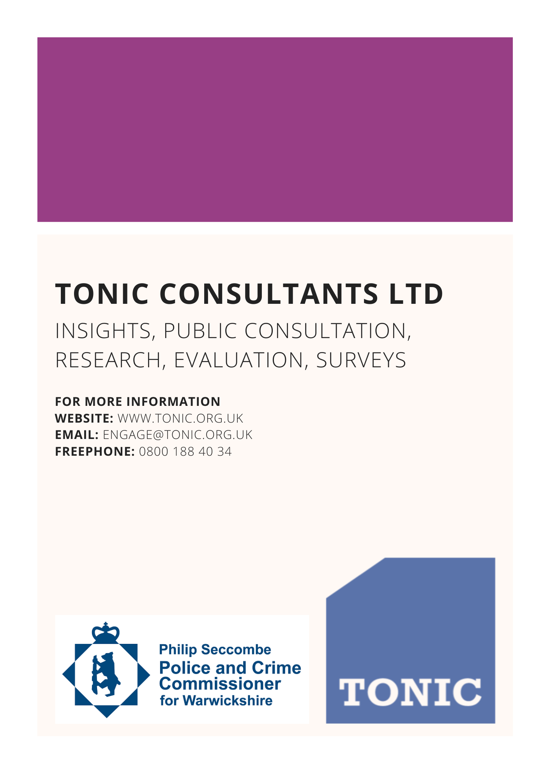

The scope of this VNA excludes: - Domestic Abuse accommodation and recovery services, as these have recently been subject to a separate joint needs assessment with Warwickshire County Council and a new service jointly commissioned. - Services provided in relation to the Sexual Assault Referral Centre (SARC). These are subject to a separate regional joint commissioning process coordinated by NHS England & NHS Improvement (NHSEI). - Victims and survivors of fatal/serious injury Road Traffic Collisions (RTC). A separate needs assessment for this will be undertaken in 2022.

