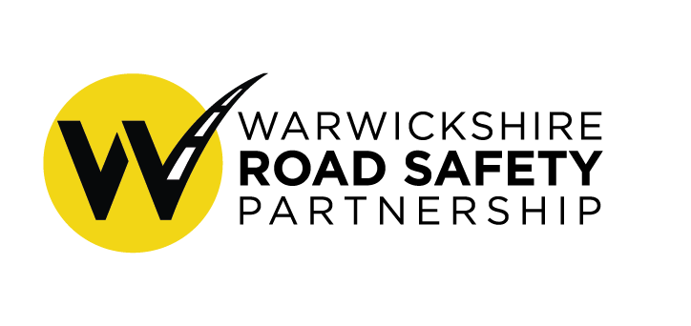

Friday 3rd December 2021
15:00pm
Virtual Meeting

Strategic Board - Minutes

Present:

Philip Seccombe (Chair- Police and Crime Commissioner)
Fay Wileman (WCC)
Warren Little (Warwickshire Police)
Ben Smith (Warwickshire police)
Rob Allen (Warwickshire Fire and Rescue Service)
Philippa Young (WCC)
Councillor Andy Crump (WCC)
Mark Ryder (WCC)
Duncan Vernon (Public Health)
Garry Palmer (WCC)
Guest: Tanya Fosdick (Agilysis)

Apologies:
Hazel Nicholas (Warwickshire Police)
Marie Biddulph (National Highways)
Faz Chisty (Warwickshire police)
Chris Lewis (Office of Police and Crime Commissioner)
David Ayton-Hill (WCC)

1 . Welcome and apologies
Board agree that the minutes of 26th August are a true and accurate record.

Action: County Council members to update on 20mph working group
The working group plan to meet in the new year and make decision regarding a blanket policy of 20mph on residential roads.
Action to be carried forward to update the board at the next meeting.

Action: Operational board to discuss speed compliance further.
Dashboard has purchased and being used by the working group

Action: Update on Operational SNAP
Information included with agenda and update will be given later in the meeting

2. Update on WRSP Strategy
Agilysis did a handover workshop of the strategy.
Principles of the safe system which must not be forgotten.
- People make mistakes that lead to road collisions.
- The human body is fragile to collisions.
- Joint responsibility to prevent death, we need individuals to comply but also the responsibility of those that build and manage the road.
- All of these parts of the system need to be strengthened.

Taking on the strategy means:
- Traffic enforcement crucial but also speed limit setting, road design, vehicle choice, post collision.
- Strong governance and accountability
- Belief in the 50% reduction by 2030 target
- Strong communications internal and external – particularly the public.
- Shared responsibility which avoids a blame culture and support road users through bringing on board the community.
- Ensuring safe system philosophy into your partnership thinking.
- Monitoring safety performance indicators.

Board thanked Agilysis for their work on the strategy.

Next step is training regarding the safe systems approach for partners.
ACTION: FW and PY to following up with TF on training on the safe system approach.

Warwickshire County Council is starting a community powered initiative which road safety could play a part in and help engage with communities.

Board agrees to adopt the Partnership Strategy to 2030

Updates of WRSP Working groups

Board discusses the proposed lead agency and identified representatives for each working group.

Discussion regarding resourcing the group. All partners happy they would be able to resource the groups.

Reassurance that the partnership coordinator will sit on each working group to ensure initiatives overlap and focus on the system as a whole and will communicate the work up to the Operational and Strategy board.

Board agrees on lead agency for each working group and representatives.

ACTION: FW will speak to strategic board members regarding appointing a chair for each working group.

3.Operational Board Grant Scheme
Discussion by the board on an engineering policy for the operational board grant scheme. Proposal for engineering works to be directed relevant highway authority and then if not successful assessed against a criterion.

Decision by the board to increase the cluster site limit up to 20 and where they are an identifiable treatable pattern to be included. Also include the option to treat roads which are classed as risky but may not fall within the top 20 cluster sites.

Decision for this policy to reviewed on a yearly basis.

Board agreed to adopt a policy on engineering works through the grant scheme

4.Communications Sub-group Update

The website is working well with over 3,500 visitors.

Positive engagements on the social media accounts with the Park it Right campaign having 7,000 impression on twitter and reaching 57,300 on Facebook.

Aim to publish the Strategy to 2030 on the website in January.

From BRAKE road safety week an online campaign for road safety heroes and partnership face-to-face events were carried out across the county.

The partnership E-scooter campaign received national recognition.

Currently promote the Christmas drink and drug drive campaign.

Board thanked Hazel for all her work.

5. Commissioning data work

For the Safety Performance Indicator for the Safe Roads working group, there is a need to develop a rating system for our roads which will then use as a benchmark and create a target. The rating system will then be monitored 3 times over the decade.

Seeking from the board to develop a commission for us to develop a tool to assess a road network in Warwickshire. Looking to commission through Warwickshire’s tendering process to develop software.

Board approved continuing work on commissioning data work.

6. Partnership apprentice

Proposal to bring in an apprentice post to support the coordinator. Road Safety GB has recently launched a road safety apprenticeship programme and need to see if this is suitable. Looking to fund from the WCC funding.

Board agrees in principle to take this forward.

7.Updates from current working groups

School Parking Working group- They have created a tiered approach to school parking giving schools resources to encourage safe parking and active travel. The group are also looking at E-scooters and are surveying secondary school headteachers.

Speed Working Group- They are using the speed compliance dashboard to stress test the framework for the central reporting system. The dashboard has been compared against surveys and is seen as reliable data. The group are now working on the website design for the system. The timeline for this project is April for testing and training with a launch to the public in May/June.

A small working group was set up to promote and mark the world day of remembrance for road traffic victims. A Toolkit was created, which was to help faith and community leaders mark the day and included poems and readings and details of support services. Work continues to create a memorial page as of part of the partnership website so family and friends can leave message about loved ones they have lost.

8.Updates on current road safety initiatives and priorities

Office of Police and Crime Commissioner
Philip is now a director and Trustee for Road Safety Trust. Also been appointed as the reginal PCC chair for Road Safety.

Warwickshire County Council
Contract has now been awarded for the average speed cameras and press release has now been released.

Discussion regarding replying to consultation as a partnership. Decision for working group to lead on replying to consultation.

Warwickshire Police
- 40 vehicles seized as part of no insurance week.
- Targeted locations as part of Brake Road Safety Week.
- Commercial vehicle unit will move to sit under the reactive unit (OPU). There will be the aim of having least one partnership activity each week in the new Year.
- Road Safety Unit have identified top 20 locations for their mobile units to go
- Community speed watch hugely successful over the last year with 63 schemes in place.
- Op SNAP has had 1460 submissions this year which translated 316 prosecutions.
- There will be a large review of the safety unit.
- KSI figures over the last quarter:
    - 5 fatalities and 60 serious injuries

Public Health Update
- Health in all policies approach starts with a policy area such as road, safety, transport, education, works to understand the links and the connections to other health issues.
- Health and Well-being Board: Board often receives updates about policy issues and activities that relates to health in its widest sense and would be good to make them aware of the new partnership strategy.

Warwickshire Fire and Rescue Service
- Currently working on our overarching strategies for prevention and protection and response

Councillor Crump and Philip Seccombe lead tributes to Keiron Amos and acknowledge his sad passing.

9: Actions for Operational Board and AOB

- To carried forward the action for 20mph working group update the board at the next meeting.
- FW and PY to following up with TF on training on the safe system approach.

- FW will speak to strategic board members from the partners regarding appointing a chair for each working group.

Next Strategic Board: 10th March.

