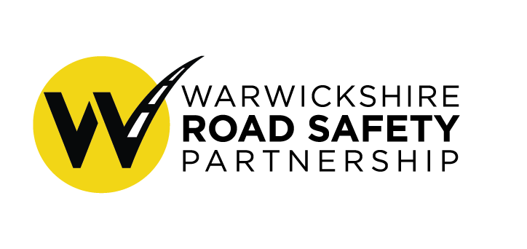
Thursday 26th August 2021
15:00pm
Virtual Meeting

Strategic Board Minutes

Welcome, apologies and attendees
Attending
Phillip Seccombe- Office of Police and Crime Commissioner (Chair)
Fay Wileman (FW) - Warwickshire Road Safety Partnership Coordinator
Andy Crump- Warwickshire County Council
Hazel Nicholas- Warwickshire Police
Warren Little- Warwickshire Police
Chris Lewis- Office of Police and Crime Commissioner
David Ayton-Hill- Warwickshire County Council
Dave Valentine- Warwickshire Police Road Safety Unit
Jem Mountford- Warwickshire Police Operational Police Unit

Apologies
Mark Ryder- Warwickshire County Council
Chief Constable Debbie Tedd- Superintendent Warren Little attending
Garry Palmer- Warwickshire County Council
Philippa Young- Warwickshire County Council
Marie Biddulph- National Highways
Nick Wells- Public Health

Note taker: Sue Parks

1. 15:00pm Minutes of last Meeting/ Matters Arising

- Minutes from the last meeting were approved by everyone present and will be signed as a true copy.
- It was confirmed that there were no specific actions other than what is on the agenda today.

2 15:10pm Update on WRSP Strategy Fay
- An update on the strategy and an interim report was presented at the last strategic board meeting, with strategic members being consulted in July on the draft strategy.
- The strategy will be used to create a short simple separate summary document which will state our vision and objectives. Both documents will be more visually appealing than the draft.
- Feedback from partners supported with the vision, structure, target and performance. Decision to change the name to ‘Communications and Engagement Working Group’ and strengthens its actions to achieve a two way conversation with Road users and residents.
- The public consultation will close on the 15th of September. The comments will be analysed. We have had 108 completed responses. Overall is possibly positive.
- Strategic board discussion on shared responsibility. Whilst certain initiatives can be targeted at groups, the focus should be on the system as a whole.
- 50% reduction target by 2030 is also going to form part of the police and crime plan as well.

3 15:20pm Update on WRSP Finances
- FW went through the funded project by the Strategic board which included, high visibility items, website design and photography.
- FW went through the funded projects by Operational Board which included; the Power 2 wheel posters, branded Bikerdown Items, community speed back packs, contribution to National Young Rider Forum, Mature Driver Assessment, community speed watch clickers and items for the SNT initiative Kids Courts.
- Conversation between members about the items being brought for the Kids Court initiative, happy for the communications group to oversee. Members asked to ensure Safe and Active travel officers are also aware of the initiative.

- Reminder to partners to promote the funding in their organisation.

4 15:30pm Communications Subgroup Hazel
- The partnership was launched on 10th of August, with a media release, social media posts and website.
- We're following around 50 Road safety related accounts and partners, around 50 are following us, on Facebook our average post reach is 7200.

- Asking board for £2,000 for a communication for designing and printing branded items such as leaflets.
£2,000 funding approved by board, funded by OPCC

- The vulnerable road users campaign runs from the 6th to the 19th September. Number of press releases planned with distribution of high visibility items and bin stickers. Also supporting Project EDWARD with safer speed day on the 15th of September with support from SNT and Community speed watch groups. Project EDWARD team will join the commercial vehicle unit on the M40.
- Results from the Anti-Speeding Campaign, 3907 drivers caught.
- Thanks, given to Hazel and Stephen for all their hard work.

5 15:40pm School Parking Subgroup Fay
- School parking group was formed in April and using the police problem solving approach. An online survey was published for a month to understand the views of headteachers, residents and parents with great partnership effort in promoting it. Received nearly 4000 responses overall, and every primary school in the county had a response.
- Now analysing results and grading the schools on a level of intervention. The aim is then to do something similar, process with the secondary schools.

- The school parking group will become the Safer Road users’ group.
- WCC have a task and finish group looking at 20mph across the county also. Also looking to explore the feasibility of School streets and piloting it in a few schools. Furthermore, the civil parking enforcement will have a new contract that allows mobile enforcement through taking photos which can be used outside schools.

ACTION: For WCC members to update the group next meeting on the progress of the 20mph working group and mobile enforcement.
6 15:55pm Speed Working Group Chris
- Group currently in discussion about the current state of the camera network. Focusing on the maintenance of the existing cameras and looking forward to average speed cameras. This will continue to develop.
- Community Speed watch we have seen the emergence of 10 new groups. OPCC are looking to put in an extra funding to help the resilience around the number of devices that are available to new groups.
- The group are hoping to fully develop a centralised reporting system. The group have created a framework to evaluate concerns and grade them. We are now looking to stress test the framework and through buying the Agilysis Speed Compliance Dashboard will allow us to successfully test the framework. The dashboard looks at the average speed for a location and number of collisions. Asking members to approve funding of £2,711 to purchase the speed compliance dashboard,
- The major positives of the scheme will allow for consistency across the county and every concern will now be given an initiative.
- Members approved the funding but ask for it to be discussed by the operational board.
ACTION: For operational board to discuss the speed compliance dashboard further and approve funding.
- Discussion regarding a 2021 remembrance event in November, support from the board.
- Members asked for an updated of Operation SNAP at the next meeting

6 16:05pm National Work
- FW gave a brief outline of the findings and recommendations from the State of Policing Report focusing on Road’s policing completed by HMICFRS. Members asked for report to be shared with the minutes.
- Warwickshire Police are currently looking at recommendations and how to respond to them. Waiting for a new NPCC Roads policing strategy as this runs out in 2021. Also a new head of NPCC, Jo Shine has been appointed.
- Looking at a new Warwickshire Roads policing strategy, as the last one was an alliance one which run out in 2020. This will include the HMICFRS recommendations and the NPCC Road Policing Strategy, fitting in the fit for the future policing, police and crime plan and the partnership strategy.

7 16:20pm Updates on Current Road Safety Initiative and Priorities
- Mention of HS2 fund for road safety initiatives now starting to take place and will continue to bid into.
- Members asked for further information brought to the next Strategic Board.

- Gem Mountford updated on campaigns including seatbelt, Op Vertebrae (M6 operation) and speed campaign. BikeSafe is fully booked all summer and the police and WFRS will be attending Bike Fest in Rugby. Focus in OPU on performance and encouraging officers.
- Offer from Jem to members to have a ride along with the commercial vehicle unit.

8 16:30pm Action for Operating Board and AOB
- For WCC members to update the group next meeting on the progress of the 20mph working group and mobile enforcement.
- For operational board to discuss the speed compliance dashboard further and approve funding.
- For an update from Operation Snap and HS2 Road Safety Fund at the next meeting

Next Meeting – Friday 3rd of December at 3pm

